Dear Referrer,
Please complete all fields below and return completed form to Millennium Care Services as soon as possible.

Question |  | Admin use only
Date referral made:

Have you made tel. enquiry previously? | Yes/ No  If Yes, please state date referral made and to who you spoke with.
Have you received the referral process? | Yes/ No
Initials of the person

Current address/ location:

Age:
Diagnosis and brief summary of needs:
(Please give as much detail as possible)

Type of Service Design Required:
(Please be mindful of specifics around capable environments)

Contact details of referrer – telephone and email:
Type of information required for referral to proceed:

Consider:
Risk assessments and risk management plans already in situ.
Support plans
Peron Centred Plans
Safe Me relapse prevention plans
CTR action plan
Decision support tool
MDT assessments and diagnostic reports
Tribunal or DoLS reports
Previous relevant chronology
Relevant previous incident reports

Potential timescales for assessment to proceed,

Expected date of service start

Thank you for taking the time to complete the attached form. If you have any further clarity then please do not hesitate to contact Millennium Care Services.
Kind Regards

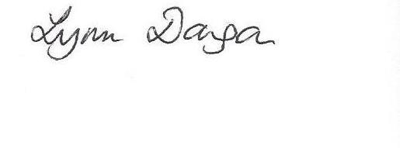
Lynn Dougan
Head of Care

